|  |  |  |  |  |  |  |  |
| --- | --- | --- | --- | --- | --- | --- | --- |
|  | | | | | | | |
| Issue:3, Vol:3 |  NEWSLETTER  **Midwest Migrant Community Network**  **Latest Updates and News** | | | | | | October 2023 – March 2024 |
|  | | | | | | | |
|  | | | | | | | |
| **Our survey and awareness raising activities**  **Sexual, Reproductive Health and well-being survey**  This survey, which we are conducting in conjunction with GOSHH, focuses on sexual and reproductive health and well-being of migrant women in the Midwest of Ireland.  If you have contact with women from Africa or Sub-Saharan Africa who live in the Midwest of Ireland, please share with them the attached poster to complete the survey.  The survey and information sessions are funded by the Department of Justice.  **The survey has been shared widely from January 2024. The survey deadline is the 22nd of March 2024.**    **Anti-racism and integration work**  We continue to be proactive in anti-racism campaigns in Limerick and the Midwest with the Integration Working Group.  We are also members of the Migrant Forum in Limerick council. | |  | |  | | | |
|  | | We contributed to the DIEN event in Thurles in October 2023. Our network member Ms.  Agnes Phiri presented on her experiences navigating the post-primary school system and University as a migrant student.  The event was well represented by researchers in Thurles, the Ombudsman for children, Dr Niall Muldoon, Ukrainian community support worker Mr Serhii Korbatsov, talks on training as a teacher with a disability and GOSHH providing a workshop on sexual health and well-being.  **The next DIEN event is on the 8th of March in Atlantic Technological University (ATU) in Sligo.** | | | |
|  | | | |
|  | |  | |
|  | | | Page 1    Page 2 | |  | | |
|  | | |  | | |

**Sexual, reproductive and well-being education and information sessions**

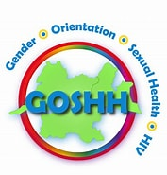

We are collaborating with our colleagues in GOSHH (Gender Orientation Sexual Health HIV), Family Planning Services and a local GP to provide information, and education on services available to migrant women in the area of sexual, reproductive health and women’s general well-being. There will be 4 sessions during the month of March 2024. See table below for dates, times and venues. **These events are FREE for migrant women to attend.**

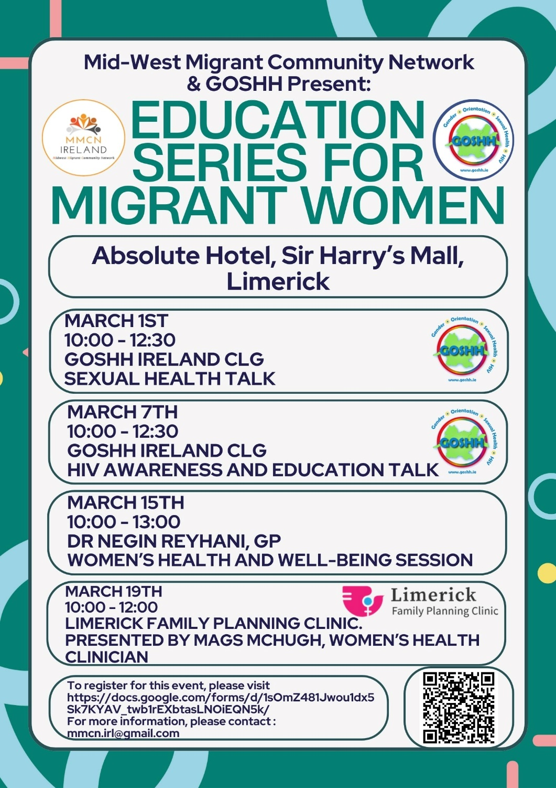



|  |  |  |  |
| --- | --- | --- | --- |
| Date | Time | Agency | Venue |
| March 1st 2024 | 9.30am Coffee & registration  10am to 12.30pm - event | GOSHH | Absolute Hotel, Sir Harry’s Mall, Limerick  [4* Absolute Hotel | Official Website | Hotel in Limerick City Centre](https://www.absolutehotel.com/) |
| March 7th 2024 | 9.30am Coffee & registration  10am to 12.30pm - event | GOSHH | Absolute Hotel, Sir Harry’s Mall, LimerickWP52  [4* Absolute Hotel | Official Website | Hotel in Limerick City Centre](https://www.absolutehotel.com/) |
| March 15th 2024 | 9.30am Coffee & registration  10am to 12.30pm - event | Dr Negin Reyhani  Women’s Health and well-being | Absolute Hotel, Sir Harry’s Mall, Limerick  [4* Absolute Hotel | Official Website | Hotel in Limerick City Centre](https://www.absolutehotel.com/) |
| March 19th 2024 | 9.30am Coffee & registration  10am to 12.30pm - event | Family Planning Services | Absolute Hotel, Sir Harry’s Mall, LimerickWP52  [4* Absolute Hotel | Official Website | Hotel in Limerick City Centre](https://www.absolutehotel.com/) |

**Registration link:** https://docs.google.com/forms/d/1sOmZ481Jwou1dx5Sk7KYAV_twb1rEXbtasLNOiEQN5k/

Please share these with migrant women who may gain further information by attending these sessions. You will need to register using the link on the official poster or via the QR code. For further information please contact GOSHH (061 314 354) or David Chisanga, MMCN ([chisangaday@gmail.com](mailto:chisangaday@gmail.com)).

Many thanks – Santhi Corcoran & Ann Piercy, Chairs - MMCN.

|  |
| --- |
| **MMCN Newsletter**  October 2023 – March 2024 Issue: 3, Vol: 3 |